What is cloud computing?



Delivery of computing services over the internet.

Cloud computing is the delivery of computing services over the internet.



Delivery of storage services over the internet.



Delivery of websites accessible via the internet.

2.

Which cloud model uses some datacenters focused on providing cloud services to anyone that wants them, and some data centers that are focused on a single customer?



Public cloud

The public cloud model provides cloud services to virtually anyone interested in using the cloud services. Datacenters are dedicated to anyone consuming cloud resources instead of a single customer.



Hybrid cloud

The hybrid cloud model is a combination of public cloud and private cloud, using both datacenters dedicated solely to one customer and datacenters that are shared with the public.



Multi-cloud

3.

According to the shared responsibility model, which cloud service type places the most responsibility on the customer?



Infrastructure as a Service (IaaS)

IaaS places the most responsibility on the consumer, with the cloud provider being responsible for the basics of physical security, power, and connectivity.



Software as a Service (SaaS)



Platform as a Service (PaaS)

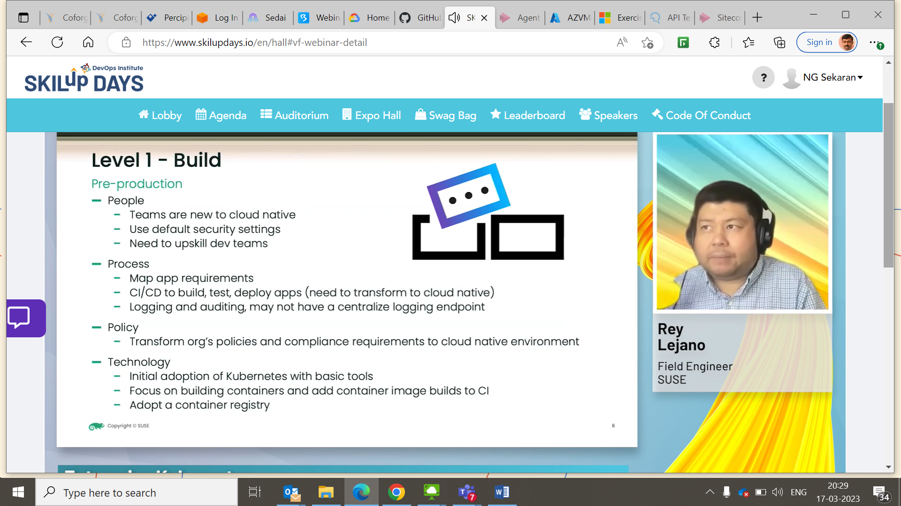

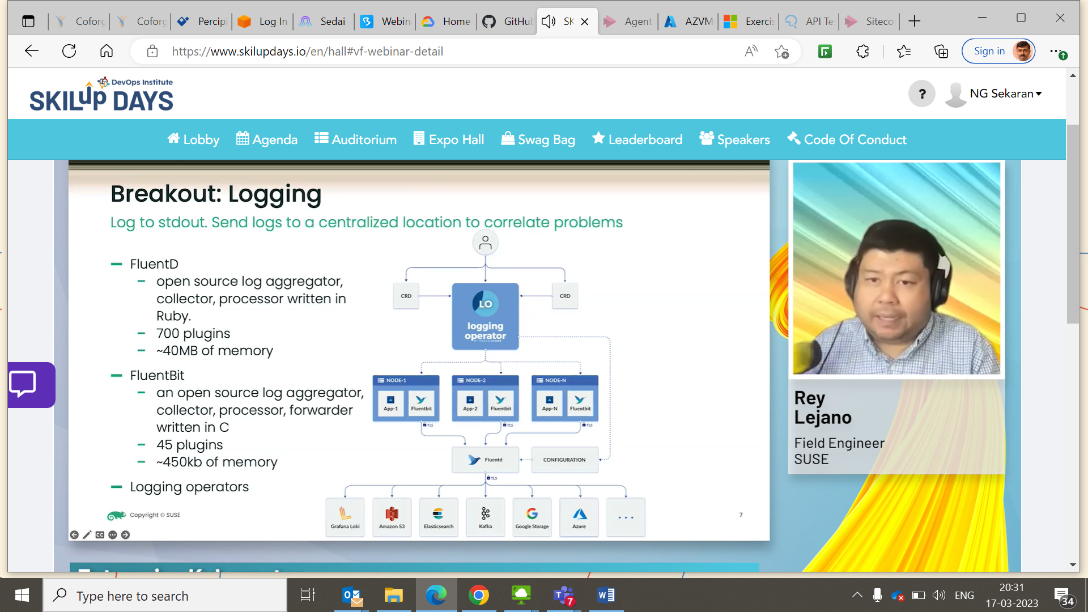

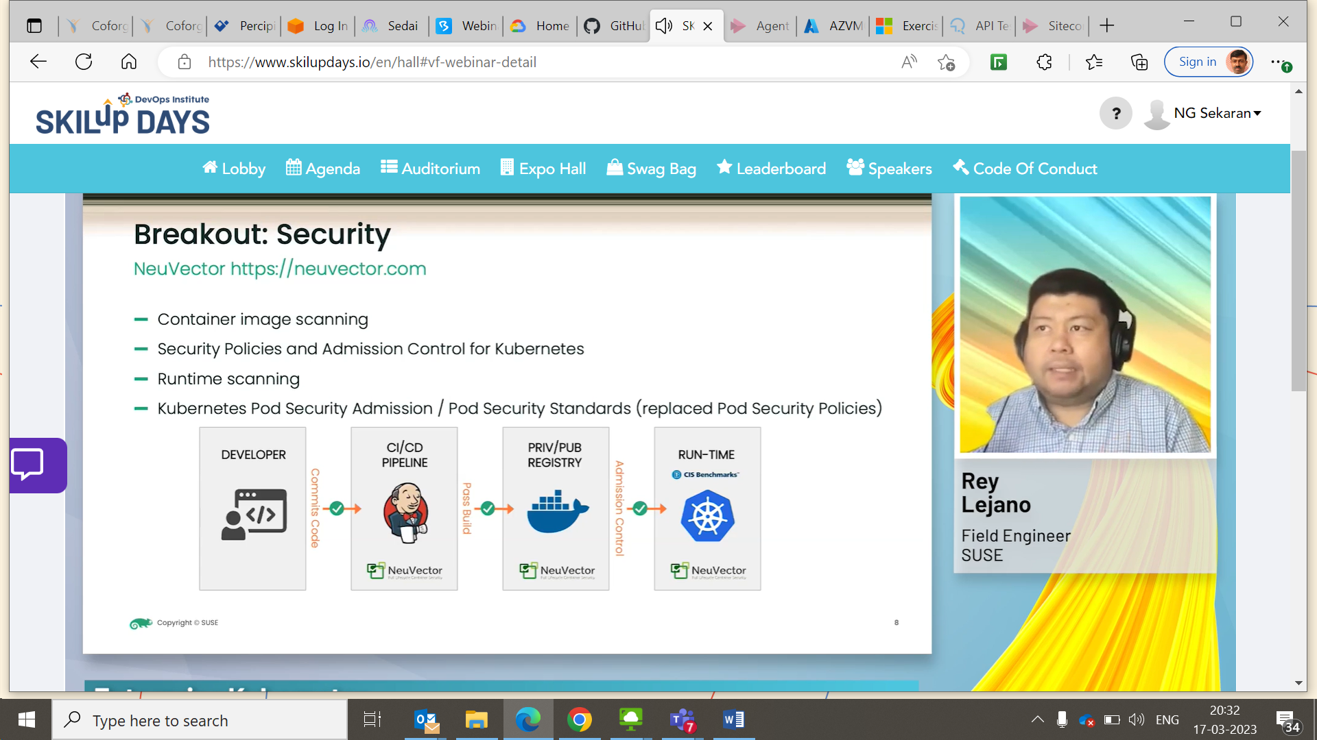

Operate moving to Prodn.

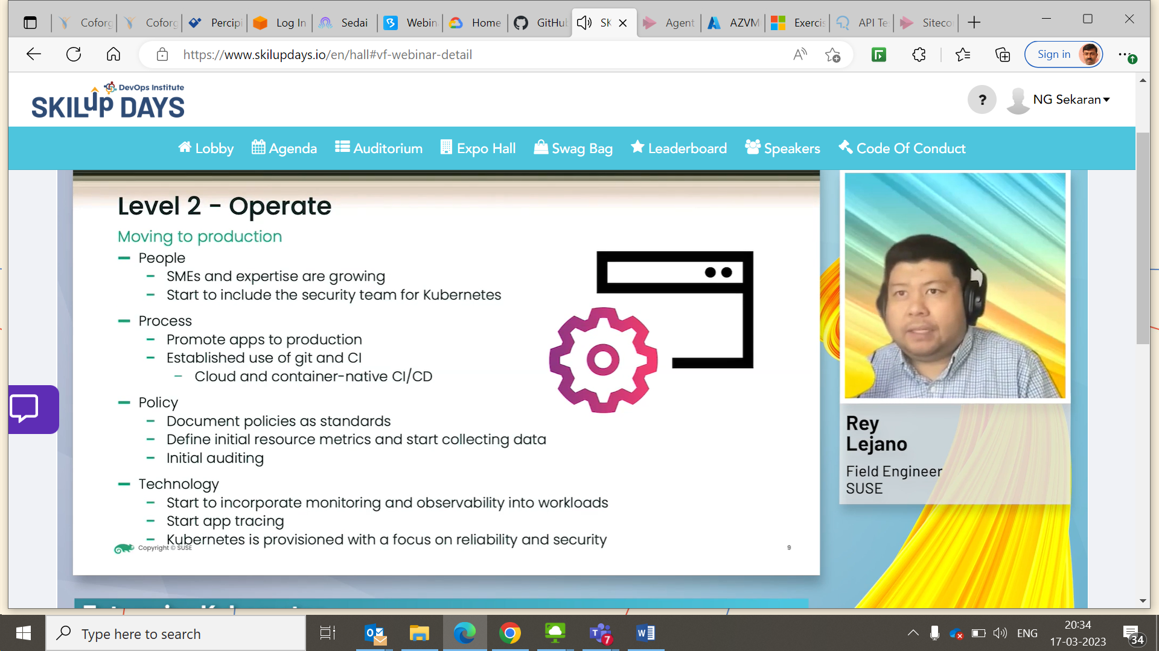

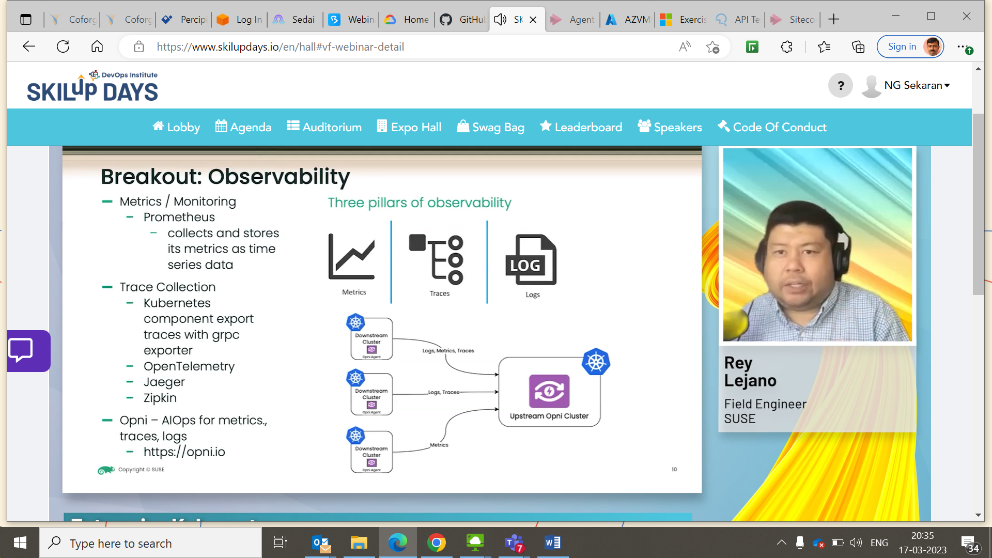

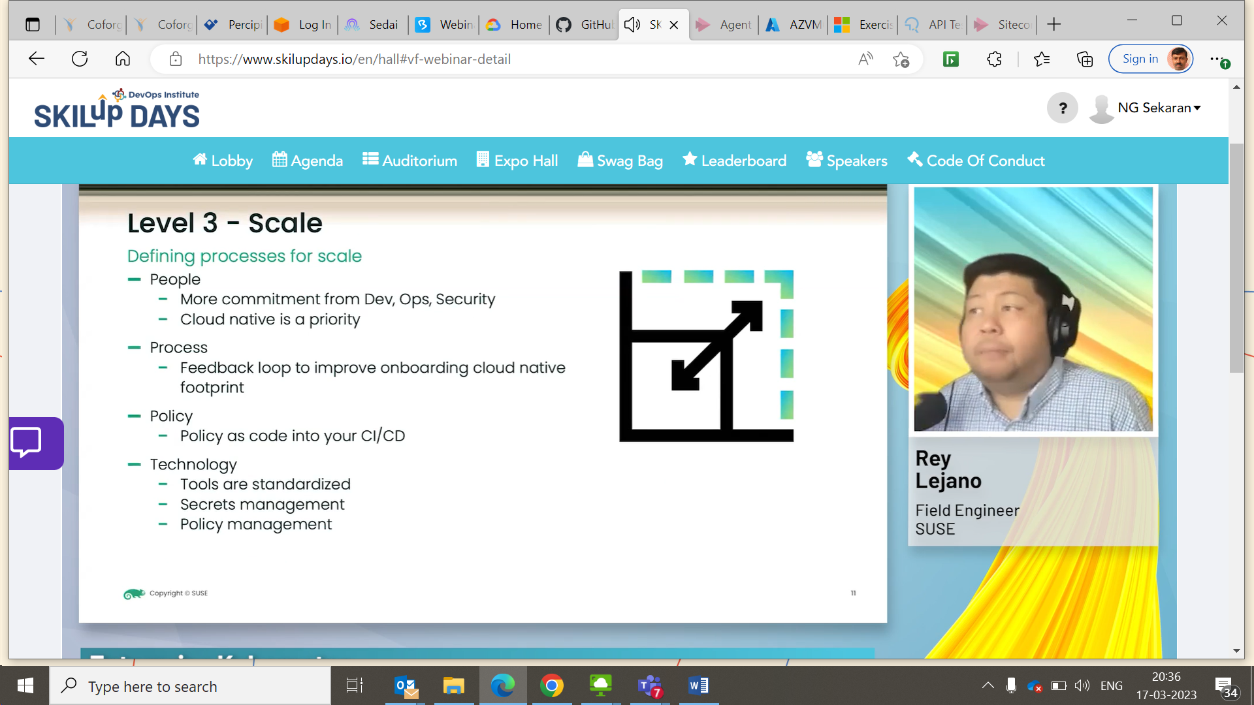

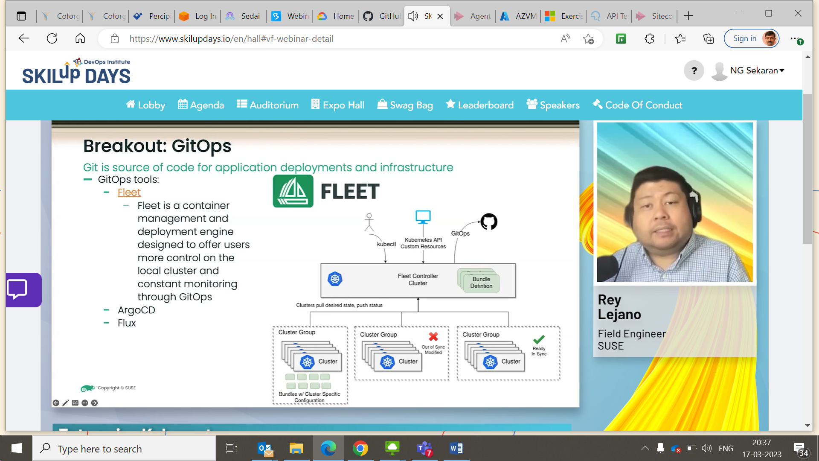

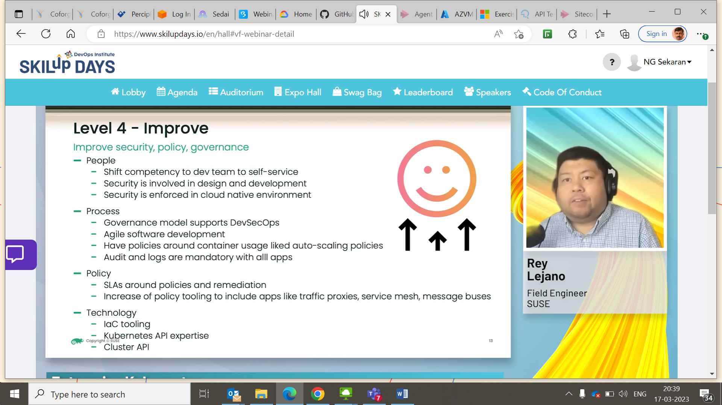

BOSIO

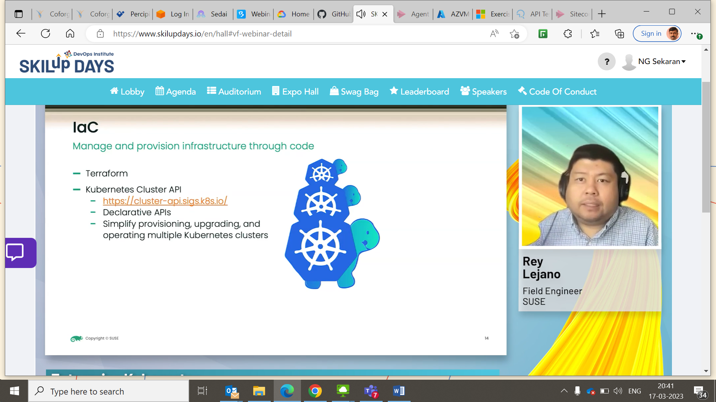

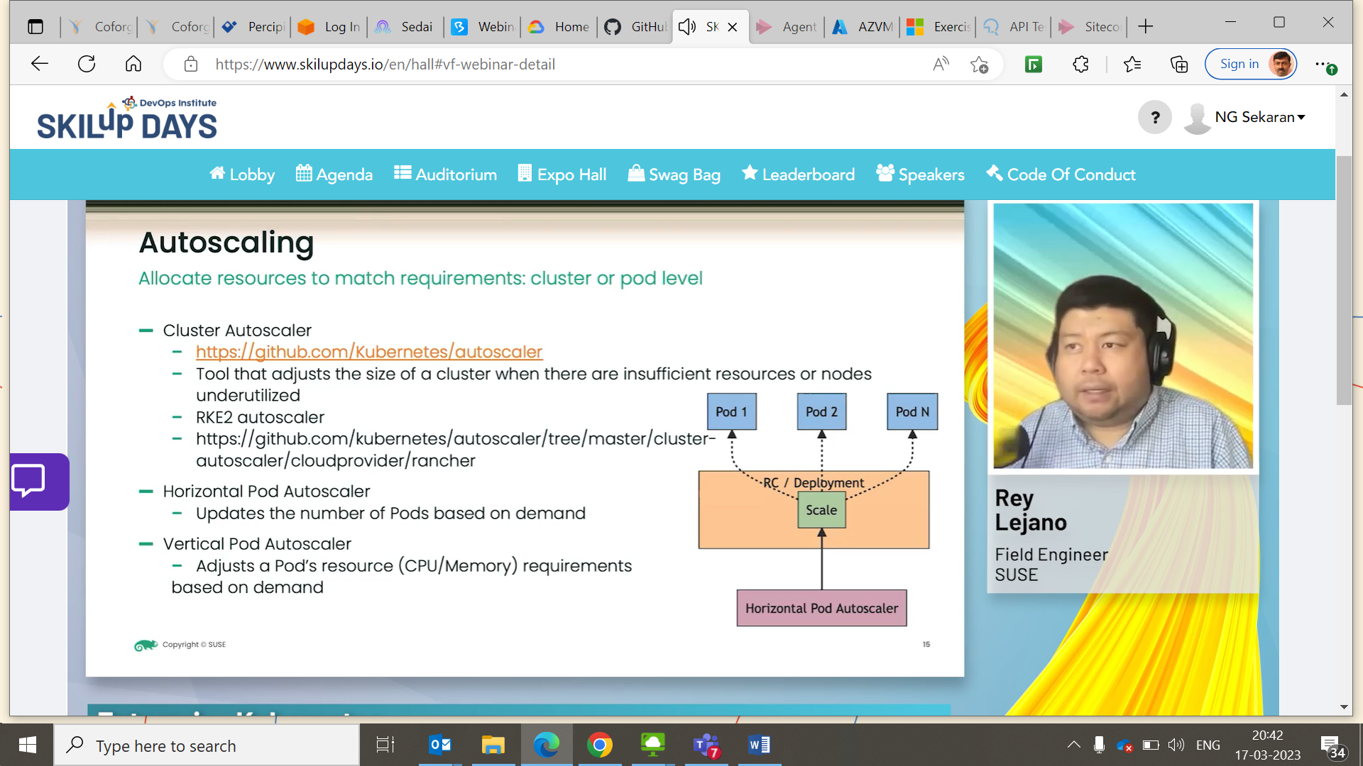

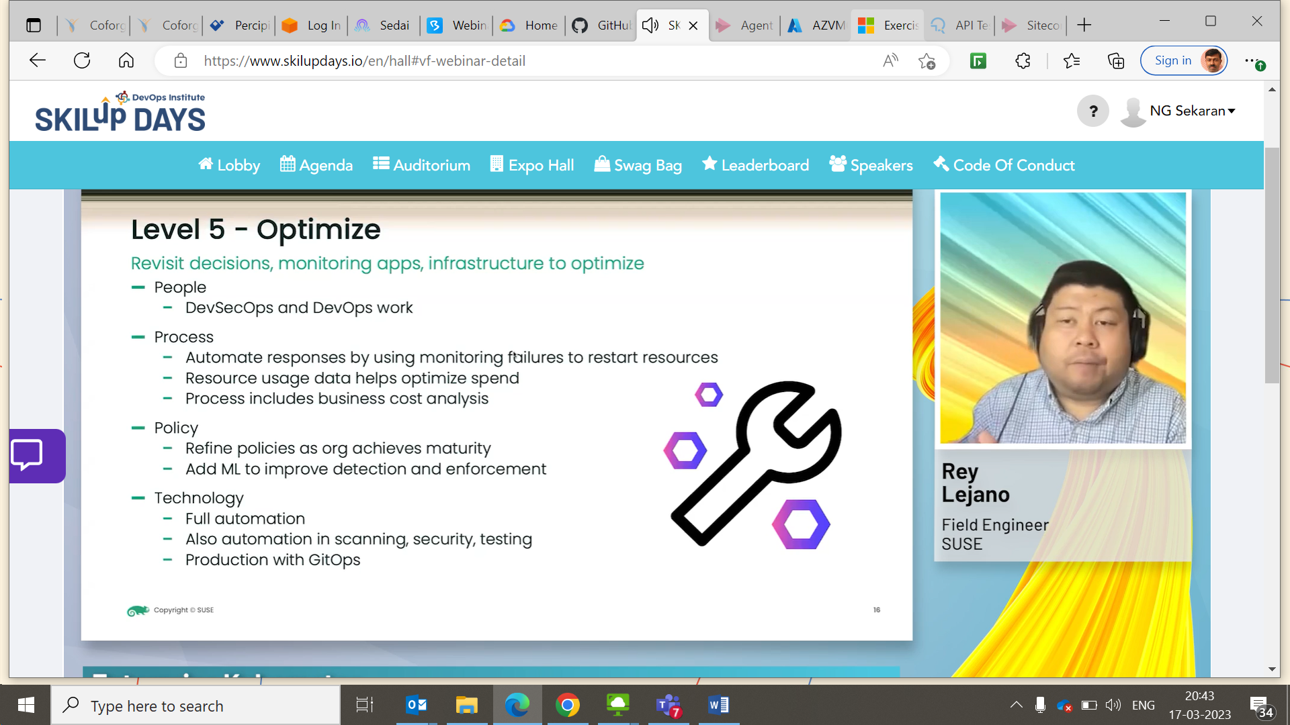

Contract Testing with Simulation

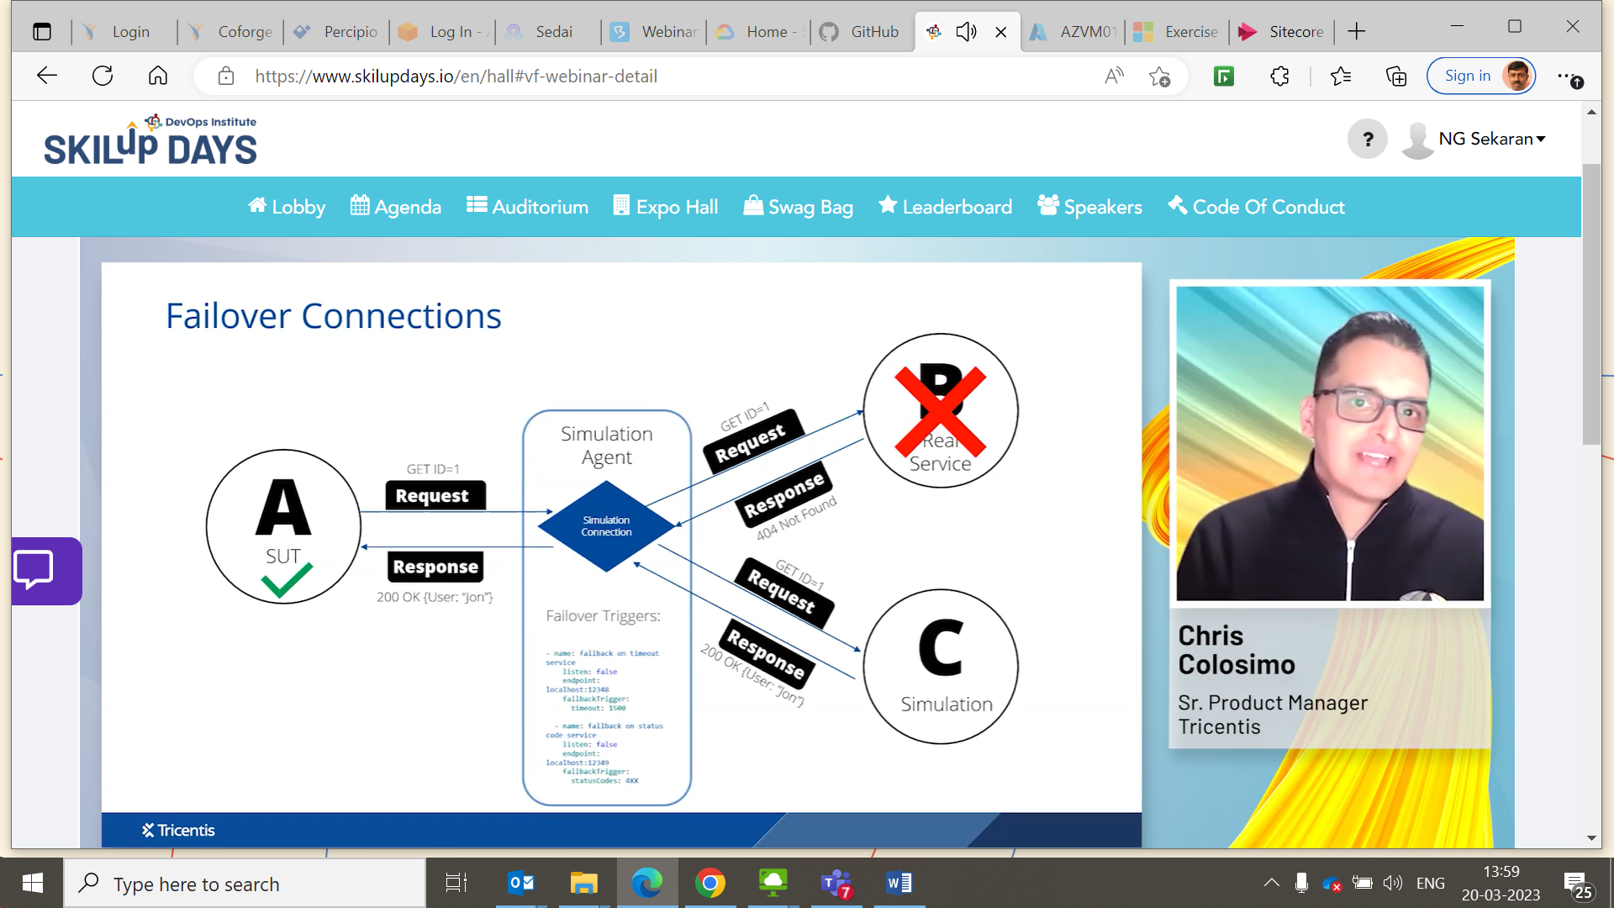

This emulates CRM system

